BOOSTIFIED—Pay Launches Live Folders for Creator Content
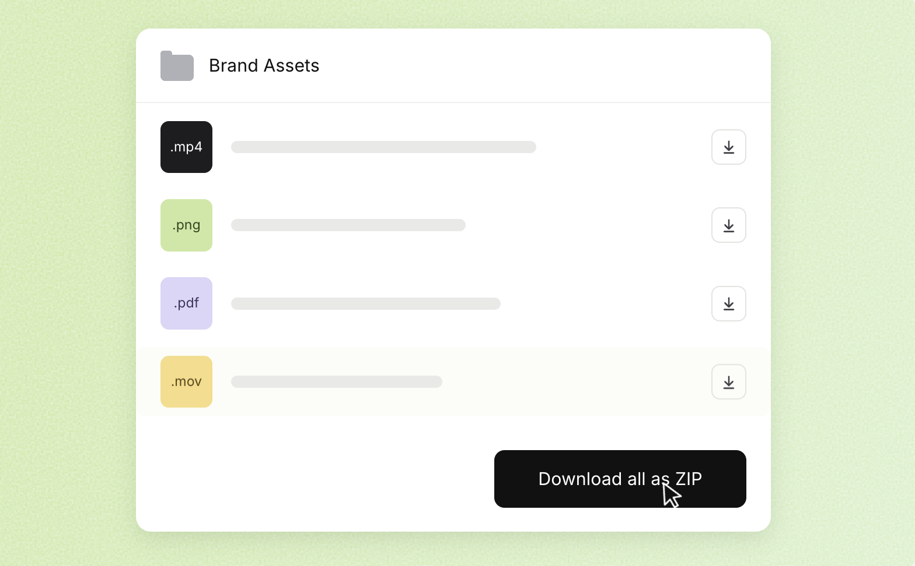
A new alternative to using WeTransfer or Google Drive for content handovers, built into the platform where creators and brands already collaborate.
Malmö, Sweden — 20 October 2026
BOOSTIFIED—Pay today launches Live Folders, allowing users to share an entire folder of images, videos and documents through a single link. As new files are added, they become available through that same link, keeping campaign deliveries, portfolios and creative assets together as a project develops.
The launch extends the platform’s existing file-sharing functionality to whole folders. Recipients can preview content, download individual files or download the entire folder as a ZIP file.

NEW FILES. SAME LINK.
A creator delivers a video. More images follow. A colleague needs the full set. Each delivery can mean another message and another place to look.
Live Folders gives that process one shared destination. Creators can share a portfolio or client delivery, while brands and agencies can make campaign content available to colleagues and partners. Adding material to the folder keeps the shared link useful throughout the project.
“The creative work shouldn’t end with everyone searching their inbox for the files. We want creators to spend more time creating, and marketing teams to spend more time using the content. Live Folders brings those handovers into the same place as the collaboration,” says Nathalie Lameri, co-founder of BOOSTIFIED—Pay.

FROM COLLABORATION TO DELIVERY
BOOSTIFIED—Pay is a CRM for UGC and creator collaborations, bringing contacts, campaign briefs, conversations and content into one platform. Live Folders adds a way to share that content beyond the workspace, directly from its Media Library.
For teams that use WeTransfer or Google Drive to hand over creator content, the feature offers an alternative within their existing collaboration workflow.
With Live Folders, users can:
- Share a complete folder through one link.
- Add new files without sending a new link.
- Let recipients preview content before downloading.
- Offer individual downloads or the full folder as a ZIP file.
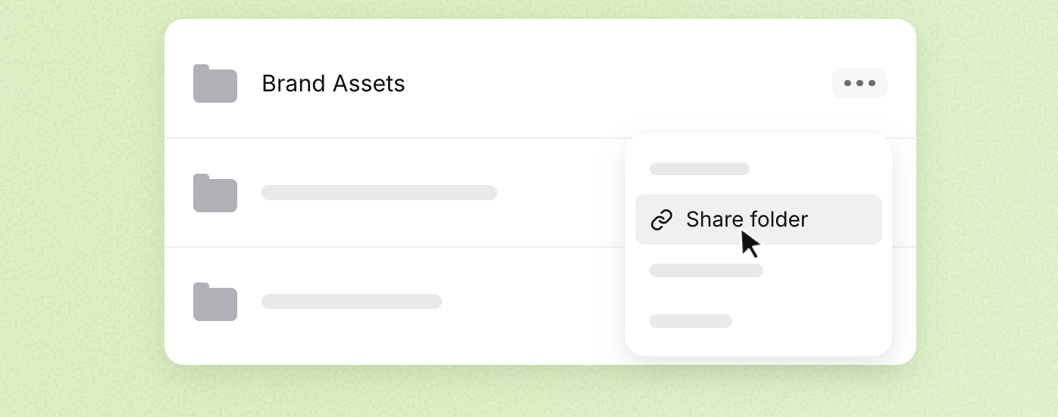

STORAGE FOR EVERY STAGE
BOOSTIFIED—Pay includes 5 GB of storage on Free and 50 GB on Personal. Freelancer, Startup and Brand include unlimited storage. Video and document uploads support files up to 3 GB each; images can be up to 50 MB each.
Live Folders is available now in BOOSTIFIED—Pay.
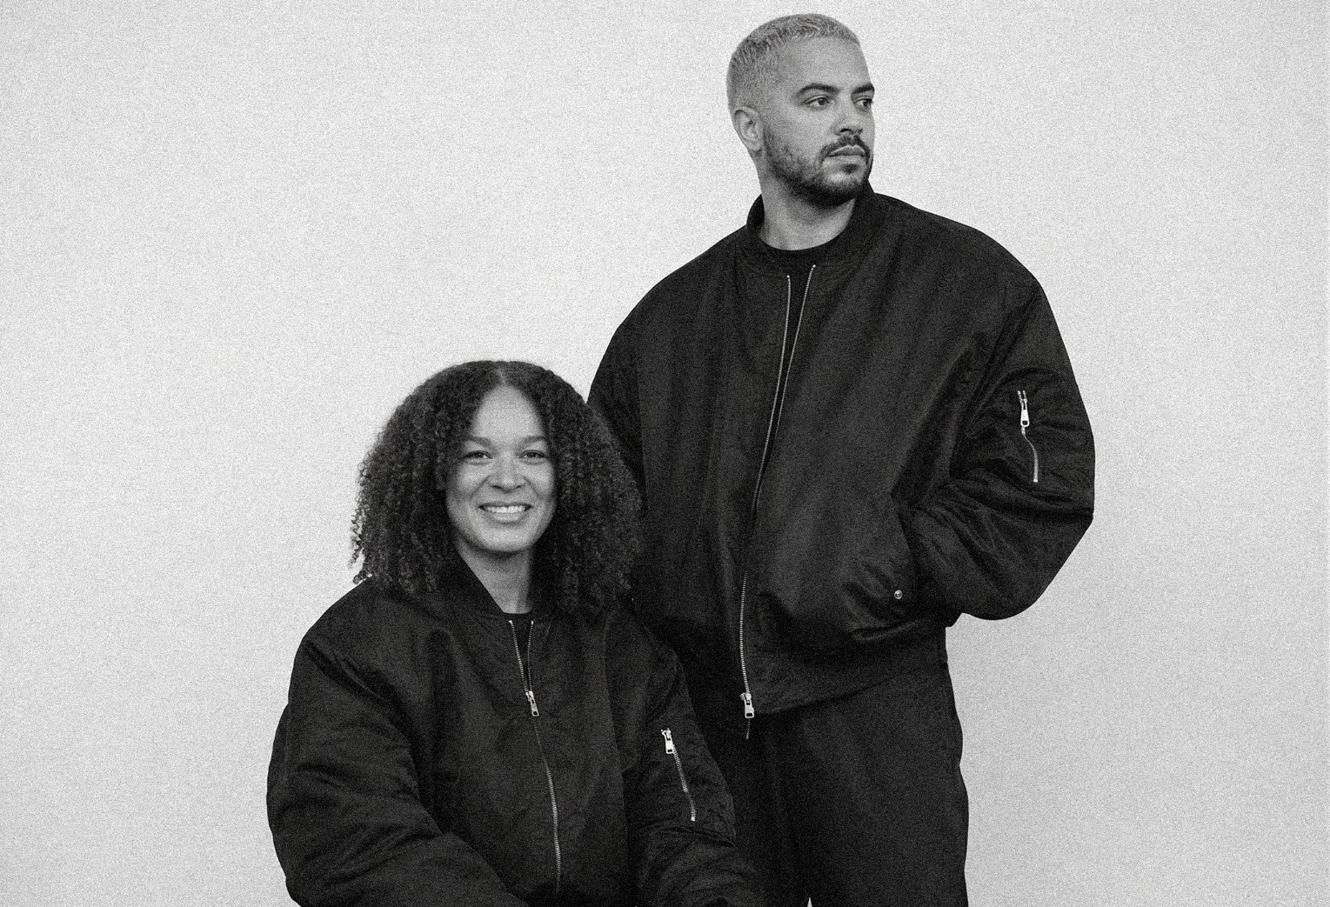
iMad and Nathalie Lameri, co-founders of BOOSTIFIED—Pay.

ABOUT BOOSTIFIED—Pay
Founded in Malmö, Sweden, BOOSTIFIED—Pay is a CRM for UGC and creator collaborations. The platform helps creators and brands find each other, build relationships and manage collaborations in one place, from the first contact and campaign brief to conversations, content and follow-up.
https://boostifiedpay.com/

PRESS
Nathalie Lameri
Co-founder, BOOSTIFIED—Pay
nathalie@boostifiedpay.com
Press materials: https://boostifiedpay.com/sv/press/

