BOOSTIFIED—Pay and StickerApp Want To Make Sticker Culture Digital

The Swedish creator platform is turning static profiles into interactive sticker spaces inspired by real-world creator culture.
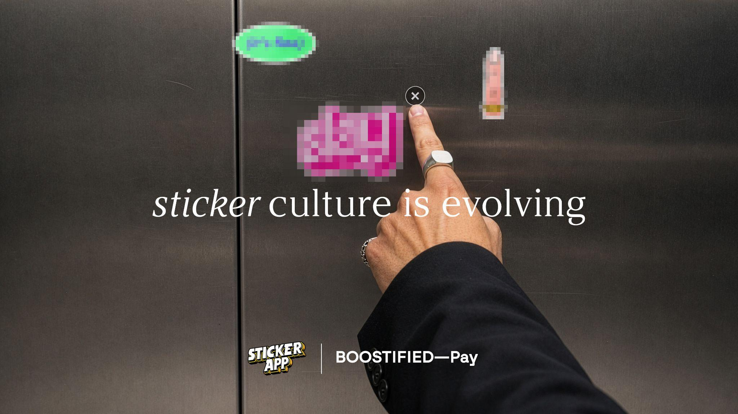

Malmö / Lomma, Sweden — 2026
Digital identity is starting to look the same everywhere.
BOOSTIFIED—Pay and StickerApp want to change that.
The Swedish creator platform has teamed up with StickerApp for MAKE YOUR MARK — a collaboration bringing sticker culture into digital identity through interactive link-in-bio profiles.
The collaboration introduces digital stickers that users can place directly on their BOOSTIFIED—Pay pages, transforming traditional link-in-bio profiles into customizable spaces inspired by real-world sticker culture. Users can interact with creators, upload their own sticker designs and personalize their pages in a more expressive and creative way — while also having the possibility to turn digital stickers into physical products through StickerApp.

FROM CLEAN PROFILES TO CREATIVE CHAOS
For years, stickers have existed inside skate culture, streetwear, music scenes and creative communities.
Not as decoration. As identity.
BOOSTIFIED—Pay wants to bring that same energy online.
Users can:
- place stickers directly on link-in-bio pages
- upload original sticker designs
- customize layouts freely
- interact with creators
- turn digital stickers into physical products through StickerApp
“Sticker culture has always been about identity and self-expression,” says Nathalie Lameri, founder of BOOSTIFIED—Pay.
“People don’t just use stickers. They create them. We wanted to build a digital experience around that behavior.”

DIGITAL STICKERS THAT FEEL ALIVE
Unlike traditional profile customization, the sticker experience inside BOOSTIFIED—Pay is designed to feel interactive rather than static.
The system includes:
- movable stickers
- layering
- dynamic placements
- creator uploads
- gravity-inspired interactions
The goal is to make digital profiles feel more human again.

PHYSICAL AND DIGITAL IN THE SAME FLOW
While BOOSTIFIED—Pay focuses on creator identity and digital interaction, StickerApp has built a global platform around premium custom sticker production.
Together, the two Swedish companies are connecting physical creativity with online expression.
Users can discover stickers digitally, build out their profiles and then produce those same designs physically through StickerApp.
The collaboration also includes:
- curated sticker drops
- creator collaborations
- community challenges
- social activations
- physical sticker releases
- limited-edition campaigns
All under the campaign title: MAKE YOUR MARK

ABOUT BOOSTIFIED—Pay
BOOSTIFIED—Pay is a creator platform and next-generation link-in-bio solution where creators and brands connect, collaborate and manage deals through customizable digital profiles. The platform gives users a more visual, personal and interactive way to showcase content, links, campaigns and creative identity online.
https://boostifiedpay.com/

ABOUT STICKERAPP
StickerApp is a global custom sticker platform helping artists, creators and brands turn designs into premium physical products.
https://stickerapp.com/

PRESS

BOOSTIFIED—Pay
Nathalie Lameri
nathalie@boostifiedpay.com

StickerApp
Magnus Hedin
magnus.hedin@stickerapp.com

